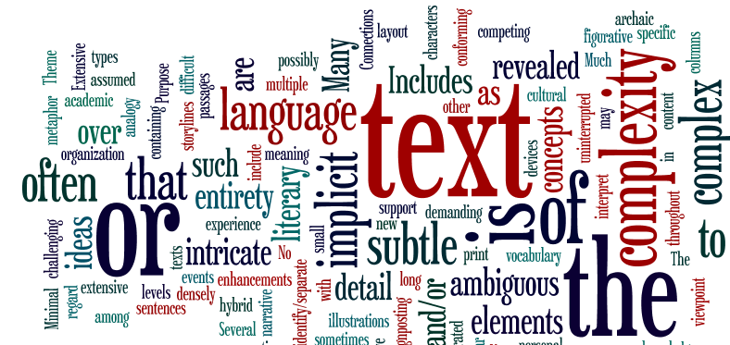
Quantitative

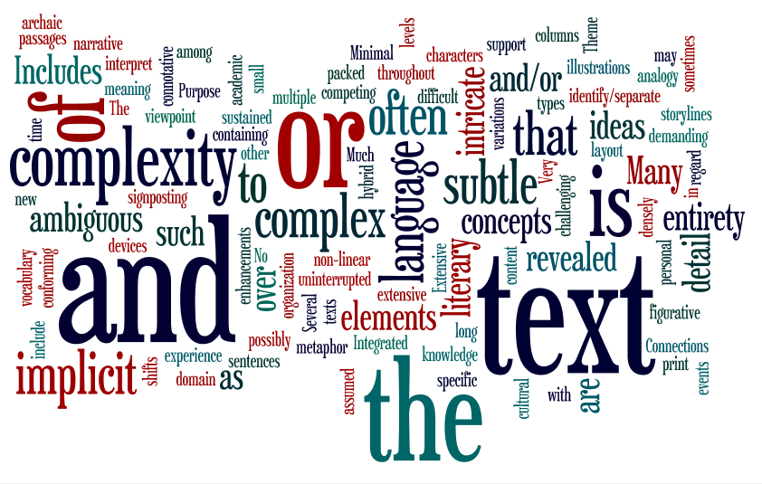
A Beginner’s Guide to
Text Complexity
AUSSIE, NYCDOE Secondary Literacy Pilot

This document addresses the issues raised around text complexity in the…

Common Core
State Standards for
English Language Arts
&
Literacy in History/Social Studies,
Science, and Technical Subjects

And in particular…
Standard 10
Range of Reading and Level of Text Complexity
10. Read and comprehend complex literary and informational texts independently and proficiently.

Introduction

The Common Core State Standards place an increasing emphasis on getting students to independently read the range and complexity of texts required to be college and career ready. The importance of both increasing the complexity of texts students read and the need for teachers to understand more about what makes their texts challenging arose out of research that showed nearly half of the students who graduate high school need some kind of remediation to cope with the reading required in college and during their careers. The research also showed that the clearest differentiator in reading between students who are college ready and students who are not is the ability to comprehend complex texts.(ACT 2006)
Students… “must also develop special skills and strategies for reading text in each of the differing content areas (such as English, science, mathematics and history)— meaning that a student who “naturally” does well in
one area may struggle in another.”
ACT, Inc. (2006) Reading Between the Lines Iowa City, IA: Author

As students move through the grades they are faced with texts that are increasingly longer and more complex in terms of the vocabulary used, sentence structure and text organization. In middle and high schools the texts will present greater conceptual challenges, may include more detailed graphic representation, while at the same time demanding a much greater ability on the part of the reader to synthesize information.
Central to the Standards is the notion that the teacher is able to match students, texts and tasks to promote student learning. Teachers need to know whether students can independently read the range and complexity of grade level discipline-specific materials and if not, what supports and strategies they need. To do this, teachers need to have information on:
- their students as readers;
- the complexity of the texts they are using with the students, i.e. supports and challenges;
- the nature of the tasks they set (how students are going to interact with the text) and the level of support they will provide.
This guide is designed to help teachers to determine the complexity of the texts they use.

What do we mean by text complexity?
Text Complexity is
“The inherent difficulty of reading and comprehending a text combined with consideration of reader and task variables; in the Standards, a three-part assessment of text difficulty that pairs qualitative and quantitative measures with reader-task considerations.”
CCSS Appendix A
There is no exact science for determining the complexity of a text. Nor is there a single source of information that can accurately summarize the complexity of a text. Teachers need to use their professional judgment as they take into consideration a range of factors.
Three Part Model
The Common Core Standards introduce a three-part model for measuring text complexity. Teachers need to use their professional judgment as they draw on information from all three sources when determining the complexity of a text.
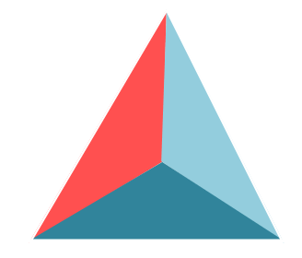
1 Qualitative Measures
The qualitative measures of text complexity require an informed judgment on the difficulty by considering a range of factors. The Standards use purpose or levels of meaning, structure, language conventionality and clarity and the knowledge demands as measures of text difficulty. (pg 6, CCSS Appendix A)
2 Quantitative Measures
Quantitative
Qualitative
Quantitative measures of text complexity use factors such as sentence and word length and frequency of unfamiliar words to calculate the difficulty of the text and assign a single measure (grade level equivalent, number, Lexile etc). There are many formulas for calculating text difficulty and, while they provide a guide, the readability or difficulty level of a text can vary depending on which formulas or measures are used. (pg 8, CCSS Appendix A)
The Standards’ Model for Text Complexity
Reader and Task
3 Reader and Task
The third measure looks at what the student brings to the text and the tasks assigned. Teachers need to use their knowledge of their students and the texts to match texts to particular students and tasks. (pg 9, CCSS Appendix A)
How do we determine the complexity of texts?
The Common Core Standards raise the expectation for students in terms of the complexity of the texts they read. This means teachers need to be familiar with the level of complexity expected at the grade levels they teach and how these compare to the complexity of the texts they use in their classes. Several considerations should guide teachers in selecting their texts and designing text-based instruction.
- Quantitative Measures
The quantitative measures provide a very useful guide in determining the complexity of texts. They are, however, not sufficient when used in isolation. Most publishers give grade band equivalents, or Lexile levels, for their texts. A book with a Lexile of 1200 will be considerably more complex than one with a 770 Lexile. The quantitative measure indicates how complex a text is, but does not explain the nature of the complexity. Quantitative measures are determined using readability formulas.
Qualitative
Quantitative
Readability Formulas
There are five readability formulas that are commonly used to measure the complexity of texts. While all can be calculated manually, there are computer programs that calculate readability when you paste in a section of 100-200 words. For instance, lexile.com, offers a free readability analysis using the Lexile framework, and provides results that are aligned to the Common Core State Standards. Other commonly used readability formulas include:
The Flesch Reading Ease Readability Formula and the The Flesch-Kincaid Grade Level Readability Formula calculate difficulty using sentence length and number of syllables per word.
Gunning’s Fog Index (or FOG) Readability Formula uses sentence length and percentage of Foggy words (words with three or more syllables).
The Dale-Chall Readability Formula uses sentence length and percentage of difficult words (words that do not appear on the familiar word list).
The quantitative measures are not sufficient in themselves. There is no question that sentence length, number of syllables in words, and word frequency impact difficulty. There is a wide range of factors that influence the complexity of a text. To be able to match students and texts, teachers need to know where the complexity lies within a text to ensure they provide students with the supports and strategies needed to successfully read the texts.
See appendix A of this guide for more detail on readability formulas.

2. Qualitative factors for describing complexity
The organization of the text is intricate with regard to elements such as narrative viewpoint, time shifts, multiple characters, storylines and detail
Connections among events or ideas are implicit or subtle throughout the text
Includes sustained complex text types and hybrid or non-linear texts
Many complex sentences, often containing intricate detail or concepts
Qualitative measures of text complexity provide valuable information when making decisions about the complexity of the text and how it could best be used with students. The Common Core State Standards identify a range of qualitative factors that interact to contribute to the overall complexity. Rubrics have been developed for both literary and informational texts that include descriptors for:
- layout;
- purpose and meaning;
- text structure;
- language features;
- knowledge demands.
Not all descriptors described in each of the categories will necessarily occur
together at each level of complexity. A text may have very simple vocabulary and short, simple sentences yet still be complex because the ideas expressed are subtle.
Gradients in text complexity (Literary Texts)

By using a rubric it is easy to see where the complexity of the text lies. If teachers know what aspects of the text are likely to be challenging for students, they can make decisions about the suitability of a text and what strategies or supports students may need to read it successfully.
(Please note that this rubric is available on the Common Core Library.)

3. What about the reader and the task?
Qualitative and quantitative measures describe the complexity within the text. The Common Core’s definition of text complexity also encourages educators to consider our students and how we are expecting them to interact with the text. In any class there will be a range in the students’ ability to read complex texts. Teachers will need to use their professional judgment when making decisions about what texts to use and how they should be used. This professional judgment is dependent on the teachers’:
- knowledge of their students as readers;
- understanding of the complexity of the texts;
- ability to use a range of instructional approaches flexibly.
Tasks, like texts, become more complex as students consider ideas and information in different ways. There is a “gear shift” from locating and evaluating items of information on a topic through to locating, evaluating, and synthesizing information from several different sources.
Balancing the supports and challenges
The more complex the text, the more support students will need. Students will be introduced to increasingly complex texts throughout middle and high school. This is done through a gradual release of responsibility where complex texts are introduced in a supportive context that facilitates higher levels of independence.
Balancing the supports and challenges
Text Supports

Independent Guided Shared Read to
Text Challenges

Teacher support increases with the complexity of the text
Reading complex texts requires students to actively engage with texts as they make meaning. This requires commitment and risk taking on the part of the reader. Students will not put this amount of effort into texts that are irrelevant and uninteresting or where they see no value in the tasks assigned.


Example of Text Complexity, Literary:
The Book Thief by Markus Zusak
Exemplar Text for Grades 9-10 Text Complexity Band ( Appendix B CCSS)
Lexile: 730L
The narrator is not identified until part way through the text

The personification of death throughout the text

Much of the text is figurative with extensive use of metaphor

Figurative language

Much of the text is figurative with extensive use of metaphor

Innovative stylistic techniques are used. The most obvious is the narrator’s (Death) use of boldface text to relay certain information.

The Book Thief, continued
This text highlights the importance of not relying solely on quantitative measures. The Lexile level is 730 L, which would suggest the book is suitable for grades 3 and 4 students (see chart on pg 14 of this guide). However, it is an exemplar text for grades 9-10 in the Standards. The complexity becomes evident when the qualitative measures are used.
Students are likely to find the following characteristics challenging:
- the historical setting;
- much of the text is figurative with extensive use of metaphor, including the personification of death itself;
- the text is long – 552 pages;
- the innovative stylistic techniques used. The most obvious is the narrator Death's use of boldface text to relay certain information;
- the intertwining, multiple themes.

 | Simple Texts | Somewhat Complex Texts | Complex Texts | Very Complex Texts
Layout | Consistent placement of text, regular word and line spacing, often large plain font | May have longer passages of uninterrupted text, often plain font | Longer passages of uninterrupted text may include columns or other variations in layout, often smaller more elaborate font | Very long passages of uninterrupted text that may include columns or other variations in layout, often small densely packed print
Layout | Extensive illustrations that directly support and help interpret the written text | A range of illustrations that support selected parts of the text | A few illustrations that support the text | Minimal illustrations that support the text
Layout | Supportive signposting and enhancements | Reduced signposting and enhancements | Minimal signposting and/or enhancements | Integrated signposting conforming to literary devices. No enhancements
Purpose and Meaning | Purpose usually stated explicitly in the title or in the beginning of the text | Purpose tends to be revealed early in the text, but may be conveyed with some subtlety | Purpose is implicit and may be revealed over the entirety of the text | Purpose implicit or subtle, is sometimes ambiguous and revealed over the entirety of the text
Purpose and Meaning | One level of meaning | More than one level of meaning, with levels clearly distinguished from each other | Several levels of meaning that may be difficult to identify/separate | Several levels and competing elements of meaning that are difficult to identify/separate and interpret
Purpose and Meaning | Theme is obvious and revealed early in the text | Theme is clear and revealed early in the text, but may be conveyed with some subtlety | Theme may be implicit or subtle, is sometimes ambiguous and may be revealed over the entirety of the text | Theme is implicit or subtle, is often ambiguous, and is revealed over the entirety of the text
Structure | The organization of the text is clear, chronological and/or easy to predict | The organization of the text may have additional characters, two or more storylines and is occasionally difficult to predict | The organization of the text may include, subplots, time shifts and more complex characters | The organization of the text is intricate with regard to elements such as narrative viewpoint, time shifts, multiple characters, storylines and detail
Structure | Connections between events or ideas are explicit and clear. | Connections among events or ideas are sometimes implicit or subtle. | Connections among events or ideas are often implicit or subtle | Connections among events or ideas are implicit or subtle throughout the text.
Structure | One text type is evident | Includes different text types | Includes different text types of varying complexity | Includes sustained complex text types and hybrid or non-linear texts
Language Features | Mainly simple sentences | Simple and compound sentences with some more complex constructions | Many complex sentences with increased subordinate phrases and clauses | Many complex sentences, often containing intricate detail or concepts
Language Features | Simple, literal language | Mainly literal, common language | Some figurative or literary language | Much figurative or literary language such as metaphor, analogy, and connotative language
Language Features | Vocabulary is mostly familiar | Some unfamiliar vocabulary | Includes much new vocabulary and some domain specific (content) vocabulary | Includes extensive unfamiliar vocabulary, and possibly archaic language
Knowledge Demands  Fiction | Little assumed personal experience or cultural knowledge | Some assumed personal experience and/or cultural knowledge | Much assumed personal experience and/or cultural knowledge | Extensive, demanding, assumed personal experience and/or cultural knowledge
Knowledge Demands  Fiction | Simple ideas | Both simple and more complicated ideas | A range of recognizable ideas and challenging concepts | Many new ideas and/or complex, challenging concepts

Text Complexity Rubric for The Book Thief

Example of Text Complexity, Informational:
“Thinking about physics while scared to death (on a falling roller coaster)” by Jearl Walker

Roundabout: Readings from the Amateur Scientist in Scientific American. New York: Scientific American, 1985.
“Thinking about physics while scared to death (on a falling roller coaster)” by Jearl Walker, continued
nominalization
Many complex sentences with increased subordinate phrases and clauses or transition words
Many complex sentences with increased subordinate phrases and clauses or transition words
Challenging abstract concepts
domain-specific vocabulary
domain-specific vocabulary

Exemplar Text for Grades 9-10 Text Complexity Band (Appendix B)
Flesch-Kincaid Grade Level puts the readability at the 8th grade level.
The language structure of this text is relatively straightforward; however, the complexity lies in the domain-specific vocabulary, complex embedded sentences and the difficulty of the ideas being explained.
Students are likely to find the following characteristics challenging:
- the domain-specific vocabulary;
- the knowledge demands of the physics concepts of motion and force;
- small, densely packed print;
- nominalization;
- minimal use of diagrams, e.g. to show directions of forces.
 | Simple Texts | Somewhat Complex Texts | Complex Texts | Very Complex Texts
Layout | Consistent placement of text, regular word and line spacing, often large plain font | May have longer passages of uninterrupted text, often plain font | Longer passages of uninterrupted text may include columns or other variations in layout, often smaller more elaborate font | Very long passages of uninterrupted text that may include columns or other variations in layout, often small densely packed print
Layout | Graphics and pictures that directly support and help interpret the written text | Graphs, pictures, tables, charts  that directly support the text | Essential integrated graphics, tables, charts, formula (necessary to make meaning of text) | Extensive, intricate, essential integrated tables, charts, formulas necessary to make meaning of text
Layout | Simple indexes, glossaries | Indexes, glossaries, occasional quotes, references | Quotes, concluding appendices, indexes, glossaries, bibliography | Abstracts, footnotes, citations and detailed indexes, appendices, bibliography
Layout | Supportive signposting and enhancements | Reduced signposting and enhancements | Minimal signposting and/or enhancements | Integrated signposting conforming to disciplinary formats. No enhancements
Purpose and Meaning | A single or simple purpose conveying clear or factual information | Purpose involves conveying a range of more detailed information | Purpose includes explaining or interpreting information | Purpose may include examining/evaluating complex, sometimes theoretical and contested information
Purpose and Meaning | Meaning is clear, concrete with a narrow focus | Meaning is more involved with a broader focus | Meaning includes more complex concepts and a higher level of detail | Meaning is intricate, with abstract theoretical elements
Structure | The organization of the text is clear or chronological and/or easy to predict | The organization of the text may include a thesis or reasoned explanation in addition to facts | The organization of the text may contain multiple pathways, more than one thesis and/or several genres | The organization of the text is intricate or specialized for a particular discipline
Structure | Connections between ideas, processes or events are explicit and clear. | Connections between some ideas, processes or events are implicit or subtle | Connections between an expanded range ideas, processes or events are deeper and often implicit or subtle. | Connections between an extensive range ideas, processes or events are deep, intricate and often implicit or subtle.
Structure | One text type is evident | Includes different text types | Includes different text types of varying complexity | Includes sustained complex text types and/or specialized, hybrid text types
Language Features | Mainly simple sentences | Simple and compound sentences with some more complex constructions | Many complex sentences with increased subordinate phrases and clauses or transition words | Mainly complex sentences, often containing multiple concepts
Language Features | Simple language style, sometimes with narrative elements | Increased objective style and passive constructions with higher factual content | Objective/passive style with higher conceptual content and increasing nominalization | Specialized disciplinary style with dense conceptual content and high nominalization
Language Features | Vocabulary is mostly familiar | Vocabulary includes some unfamiliar, context-dependent words | Includes much academic vocabulary and some domain specific (content) vocabulary | Includes extensive academic and domain specific (content) vocabulary
Knowledge Demands  Informational | General topic is familiar, with details known by reader | General topic is familiar, with some details new to reader | General topic is somewhat familiar but with many details unknown to reader | General topic is mostly unfamiliar with most details unknown to reader
Knowledge Demands  Informational | Simple, concrete ideas | Both simple and more complicated, abstract ideas | A range of recognizable ideas and challenging abstract concepts | Many new ideas and/or complex, challenging, abstract and theoretical concepts
Text Complexity Rubric for “Thinking about physics while scared to death”

Planning for Support
Professional Practice
The way in which ideas and information are presented to students and the opportunities and scaffolds provided for them to engage with texts are critical elements of teacher practice that can shape students’ success in navigating complex texts.
Teachers need to provide multiple, differentiated points of entry to texts.

Tasks, like texts, become more complex as students think about ideas and information in different ways. When considering the complexity of the text teachers need to take into account the tasks they set, as well as their knowledge of their students as readers.

When introducing texts teachers need to consider the challenges in the text and the strategies students need.
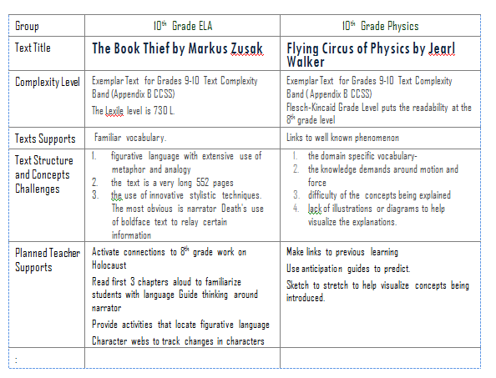

Appendix A (of “Beginner’s Guide to Text Complexity”)
Readability Formulas
There are five commonly used readability formulas. While all can be calculated manually, there are computer prgrams that do this for you by pasting in a section of 100-200 words. ©ReadabilityFormulas.com , for instance, offers a free readability analysis and gives results using the four most common used readability scores.
1. The Flesch Reading Ease Readability Formula
The specific mathematical formula is:
Readability Ease = 206.835 – (1.015 x average sentence length) – (84.6 x average syllable per word).
The higher the number, the easier the passage: 90-100, very easy and 0-29, very confusing.
2. The Flesch-Kincaid Grade Level Readability Formula
The specific mathematical formula is:
Flesch-Kincaid Reading Age = (0.39 x average sentence length) + (11.8 x average syllable per word) - 15.59
The score is given as a grade level equivalent – a score of 9.4 would be 9th grade. Flesch-Kincaid Grade Level Readability Formula is built into the MS-Word application.
3. Gunning’s Fog Index (or FOG) Readability Formula
The specific mathematical formula is:
The FOG formula takes into consideration (1) the total number of words, (2) the number of words of three or more syllables, and (3) the total number of sentences.
Grade Level = 0.4 (Average Sentence Length + Percentage of Hard Words).
Hard words are defined as words with three or more syllables.
4. The Dale-Chall Readability Formula
The specific mathematical formula is
Raw Score = 0.1579 Percentage of Difficult Words + 0.0496 Average Sentence Length in words + 3.6365
Raw scores convert to grade levels with scores 5.0 to 5.9 = Grades 5 – 6 and 8.0 to 8.9 = Grades 11 - 12
Difficult words are words that do not appear on the Chall word list of over 3000 familiar words.
5. The Fry Graph Readability Formula
The Fry readability formula uses three 100 word passages and calculates the average number of words per sentence and the number of syllables per 100 words.
.
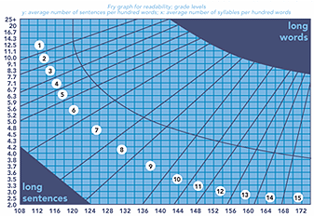
Scores that appear in the dark area (long sentences and long words) are invalid.
Many companies are in the process of adjusting their leveling systems to align to the raised expectations for standards. The following chart shows how MetaMetrics has realigned its Lexile ranges to align to expectations for College and Career Readiness.
Fig 3: Text Complexity Grade Bands and Associated Lexile Ranges (in Lexiles) – from page 8 of the Common Core State Standards, Appendix A
Text Complexity Grade Band in the Standards | Old Lexile Ranges |  | Lexile Ranges Aligned to CCR
K–1 |  | N/A | N/A
2–3 |  | 450–725 | 450–790
4–5 |  | 645–845 | 770–980
6–8 |  | 860–1010 | 955–1155
Reader and Task

To use the Lexile framework online go to: http://www.lexile.com/
To find the readability formula for a text there are two options.
--Use the “Quick Book Search” (most suitable for published books)
--Use the “Lexile Analyzer” (Most suitable for articles. A free account is required to use this function.)

