Course Blueprint

For this activity you will create a layout or “blueprint” to guide the development of your blended learning course. You may choose to revisit this plan in the coming weeks as an iterative process. However, if you are working with a course you’ve taught many times before, you may be able to complete the Course Blueprint quite easily.
Following is background information to assist you in working with the Course Blueprint template found at the end of this document. There is also a sample Course Blueprint provided for your reference.

As you proceed, you should have in mind the time divisions into which you’ve organized your course. Many faculty organize courses into “weeks,” but others use larger groupings. We’ll refer to these groupings as “modules” in this document, but you may refer to them however you wish (e.g., units, lessons, chapters, etc.). Each module has associated learning activities, readings, graded assignments, and assessments – all of which culminate into the final grade for the course.
The Course Blueprint consists of four elements which include:
- Course Description
  - It is likely that your institution’s course catalog provides a broad description of your course. This might be a good place to start. Copy, paste, and modify (if you choose to do so) your course description into the field within the Course Blueprint template located at the end of this document.
- General Course Goals
  - What are the overarching goals of your course?
- Performance Objectives
  - Each module will have objectives that you desire for your students to achieve. These should be measureable. (For assistance in creating or revising objectives, please see the online “Objectives Builder.”)
- Learning Outcomes
  - These are the assignments that students will need to complete to demonstrate proficiency in learning the material.

The sample Course Blueprint below will assist you in visualizing how you can design your own Course Blueprint. Note how the above elements relate to the structure in the sample.
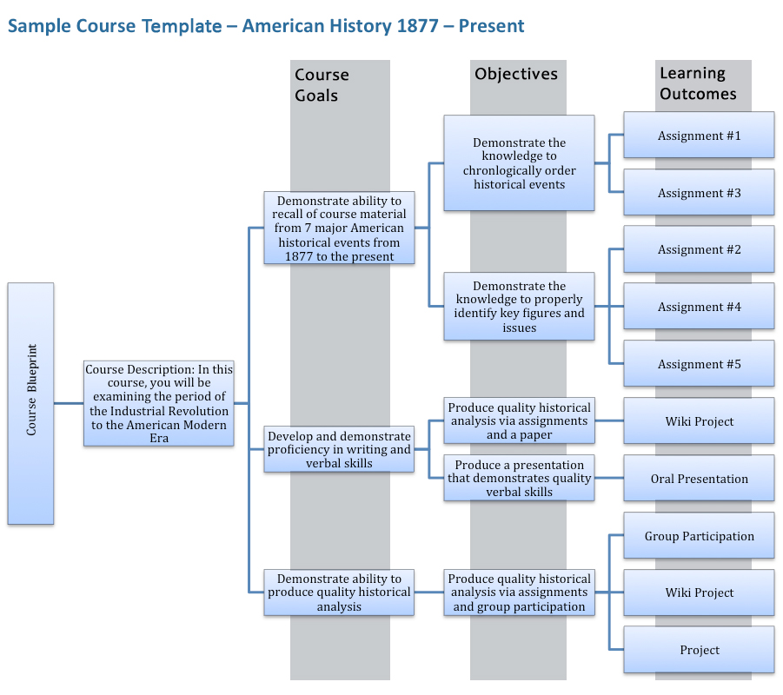
Directions:
The Microsoft Word-based diagram above is one of many tools and formats that you can use to create your own Course Blueprint. For instance, you may wish to create an outline or a concept map. Use the tool/format that is best for you. If you would like to continue to work with this Word document please review the following steps to use Word’s “SmartArt” features in the template that follows:
- Hover and click the map so that an icon appears in the left hand corner.

- Select the icon so that a text pane appears.
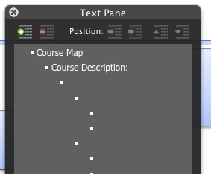

- The text pane functions as an outline that allows you to place your content into each bulleted item. The arrows will move the content up, down, left and right depending on what you choose.

- The interface if somewhat intuitive. There are additional features you may wish to explore, or you may choose to use Word’s Help feature for assistance.

Note: If you’ve added more content than the graphic can accommodate, you can reset the graphic. There is an option in your Microsoft Ribbon under SmartArt Graphic Styles (upper right hand corner) where selecting Reset Graphic will resize it automatically.

Course Blueprint – Course Title (Template)

Course Blueprint in Practice: Comparing Content of Syllabus and Modules

Syllabus

Contains:
- Course Overview
- Schedule
- Grading
- Protocols
  - What instructor expects from students
  - What student can expect from Instructor
    - Communication Expectations

Module
(Naming Options: Module, Unit, Chapter, Topic, Course Content, Course Materials)

Contains:
- Module Objectives/Goals/Outcomes
- Activities/Interaction/Assignments
  - Student-to-Student
    - Examples:
  - Student-to-Content
    - Examples:
  - Student -to-Instructor
    - Examples:
  - Student-to-Other
    - Examples:
- Assessment
  - Informal
  - Formal

