Introduction
FDA is a science based public health and regulatory agency responsible for ensuring the safety and proper labeling of foods (including dietary supplements) in the U.S. marketplace. To meet these responsibilities FDA invests significant resources in measurement and analysis, scientific methods development, original scientific research, reference database development, bioinformatics, risk analysis, and other science based activities. The work might be conducted at the lab bench, “in the field” at various geographic locations, using computer assisted computational analyses, or through surveys. Areas of investigation include but are not limited to microbiological, genomic, toxicological, and chemical research designed to evaluate the safety of products and to improve food safety practices in agricultural operations, aquaculture operations, and food processing facilities. FDA also conducts behavioral research to better understand consumers’ food safety practices in the home and how they respond to nutrition and health information presented on food labels.
Below you will find descriptions of different types of food related science and research activities FDA’s Center for Food Safety and Applied Nutrition (CFSAN) is engaged in and the activities’ applications to positive public health outcomes.

Measurement and Analysis Using Current Laboratory Methods
The laws and regulations that FDA is responsible for enforcing, and to which food manufacturers must adhere, often necessitate measuring and analyzing food products, food packaging materials, or the environments in which foods are grown, packed, or processed. These measurements and analyses are used to:
- check the values that appear on the Nutrition Facts Label and Supplement Facts Label;
- ensure that food packaging is made of materials that are understood to be safe;
- test for potentially harmful levels of chemicals in foods;
- test for the presence of foodborne pathogens or unintended allergens in a food or food processing environment;
- evaluate the effectiveness of preventive controls designed to ensure food safety; and
- provide other information that can be used to help ensure the public health.
Some of the methods used by FDA to help ensure food safety are available on FDA's laboratory methods web page. These methods may be utilized by other public health agencies, laboratories, and the food industry as well.

Scientific Methods Development
There are times when FDA needs to test a product for a particular contaminant but a validated method to test for the contaminant in that product has not been established. In these instances, FDA scientists must develop and validate a method that can detect and measure the presence and/or quantity of the contaminant in the food product of interest. When FDA does this it typically publishes the new method in a peer-reviewed journal so interested parties understand how FDA conducted its analysis and other researchers can use and adapt the method. Examples of new or modified methods developed by FDA include tests to detect and/or measure: color additives in foods, Listeria in ice cream, trans fats in oils, melamine in infant formula and other foods, polycyclic aromatic hydrocarbons (PAHs) in seafood as a result of oil spills, etc.

Original Scientific Research
The importance of science in FDA’s foods program goes beyond basic measurement and analysis. It involves applying established scientific principles and methods to better understand factors that impact food safety and nutrition. The specific issue FDA seeks to address may vary but inevitably FDA must: identify the variables believed to impact a particular public health concern; gather information about those variables using validated research methods; perform analyses to determine the impact of the variables; and assimilate the information so it can be used by FDA and others to help achieve positive public health outcomes.
Examples of research FDA has conducted include but are not limited to:
- determining if the outflow from waste water treatment plants impacts existing commercial shellfish beds;
- better understanding the persistence of foodborne pathogens in the environment and what it means for produce growing practices;
- gathering data on how consumers interpret the information on food labels and how it influences consumers’ food choices;
- understanding the source of processing-induced contaminants in foods;
- assessing components of dietary supplements;
- predicting the effectiveness of interventions or control measures to mitigate specific food safety problems;
- using whole genome sequencing to better understand the relatedness of foodborne pathogens and the routes of contamination that result in foodborne illness outbreaks;
- using DNA to identify live microbial ingredients in foods and dietary supplements; and
- using DNA as a tool to properly identify and label seafood.
The findings from these efforts are invaluable in maximizing the effectiveness of food safety practices and improving the labeling and nutrition information provided to consumers. FDA makes the results of its work available via peer reviewed journals and/or its website so other public health officials, researchers, and members of industry can also use the information.
In the case of whole genome sequencing of foodborne pathogens, FDA and its public health partners have been building GenomeTrakr, which includes a global network of laboratories and a publicly accessible reference database of genomic information and geographic information from foodborne pathogen isolates. Public health officials and industry members can use the database to speed investigations of foodborne illness outbreaks and food contamination events, ultimately reducing illnesses and deaths. Likewise, FDA is building a reference database of DNA sequences from commercial seafood species. This database is also publicly accessible and can be used by public health officials and members of industry to help confirm whether seafood is properly identified on its label. Below you will find links to the Center for Food Safety and Applied Nutrition's Research Strategic Plan and to some of the specific applied research efforts in which FDA’s foods program is engaged.












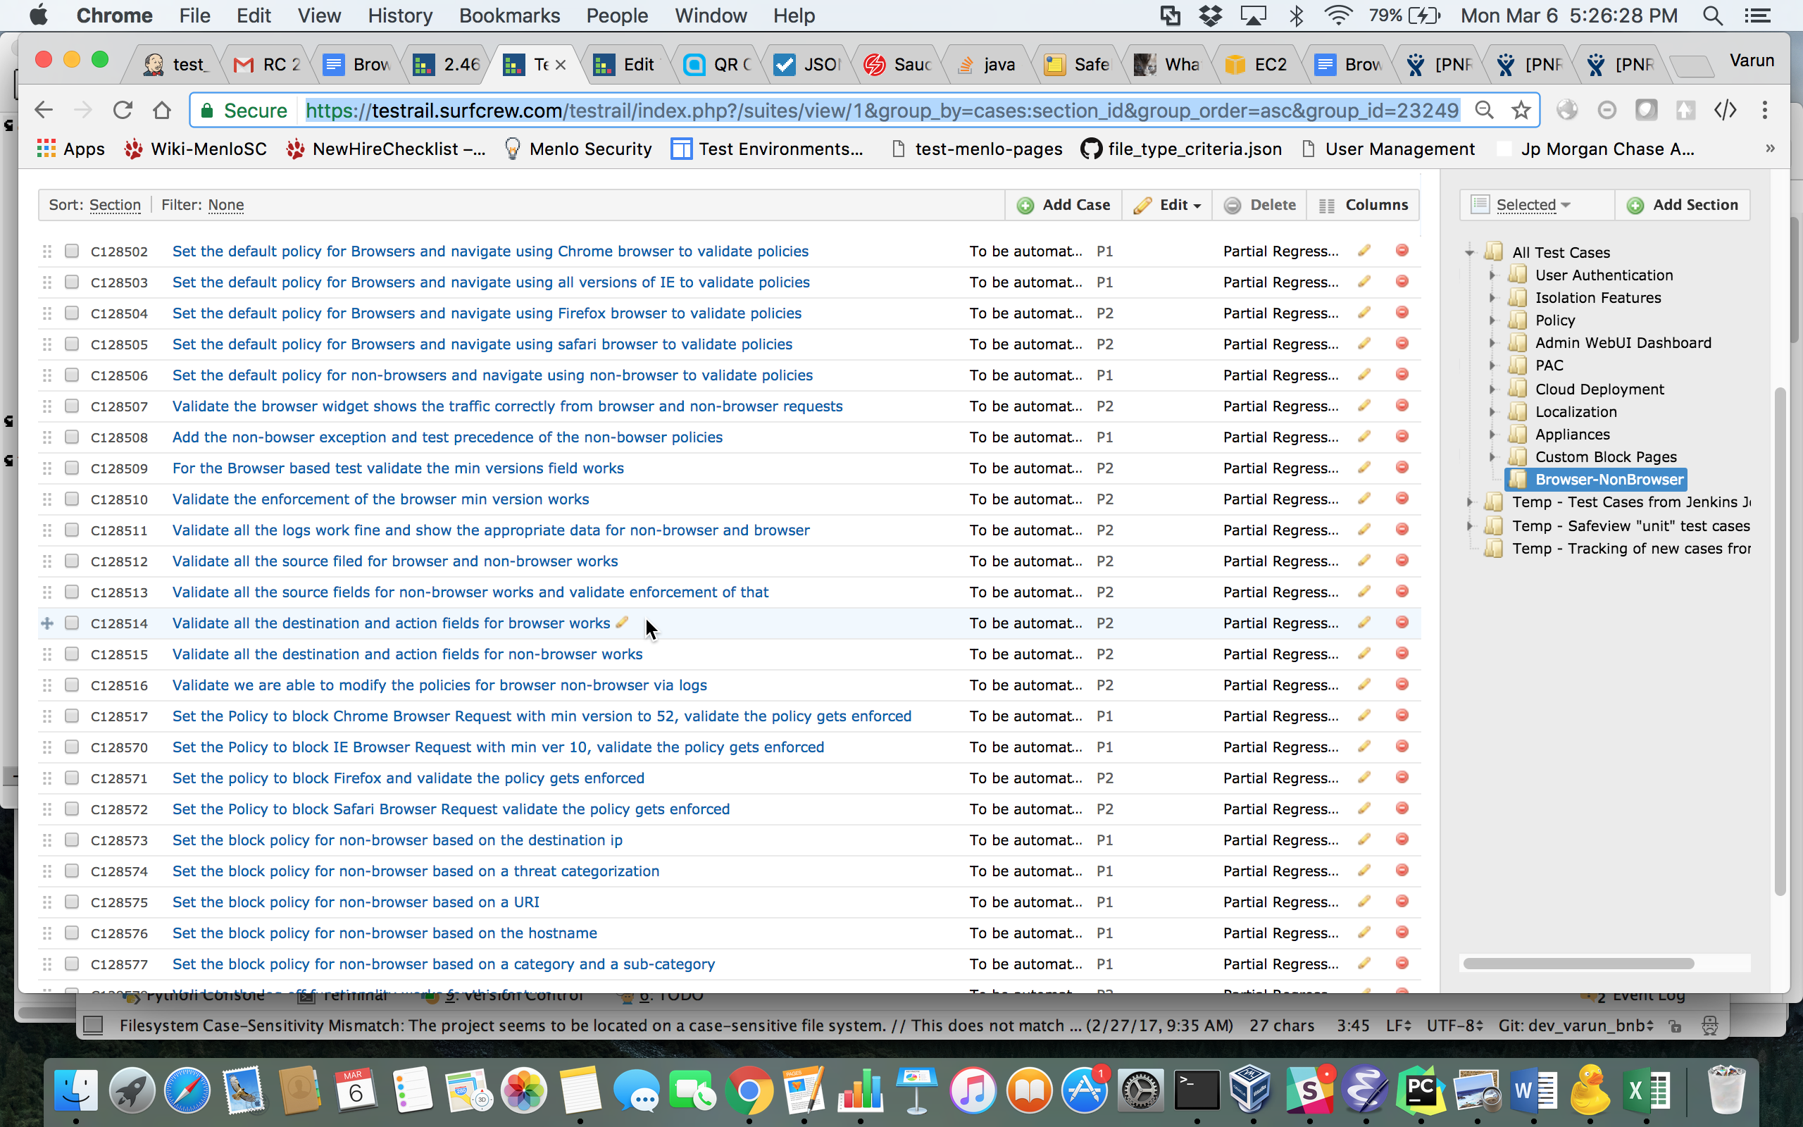Restore nodes:
Click the + icon and add the following IP address: 54.225.194.201
Click the + icon and add the following IP address: 50.16.230.34
Click the + icon and add the following IP address: 54.197.237.108
Click the + icon and add the following IP address: 54.221.216.72
Click the + icon and add the following IP address: 54.243.221.103
Click the + icon and add the following IP address: 184.73.234.203

Transform nodes:
Click the + icon and add the following IP address: 23.21.65.62
Click the + icon and add the following IP address: 54.235.203.168
Click the + icon and add the following IP address: 54.163.243.220
Click the + icon and add the following IP address: 54.225.122.232
Click the + icon and add the following IP address: 174.129.42.141
Click the + icon and add the following IP address: 184.73.162.55

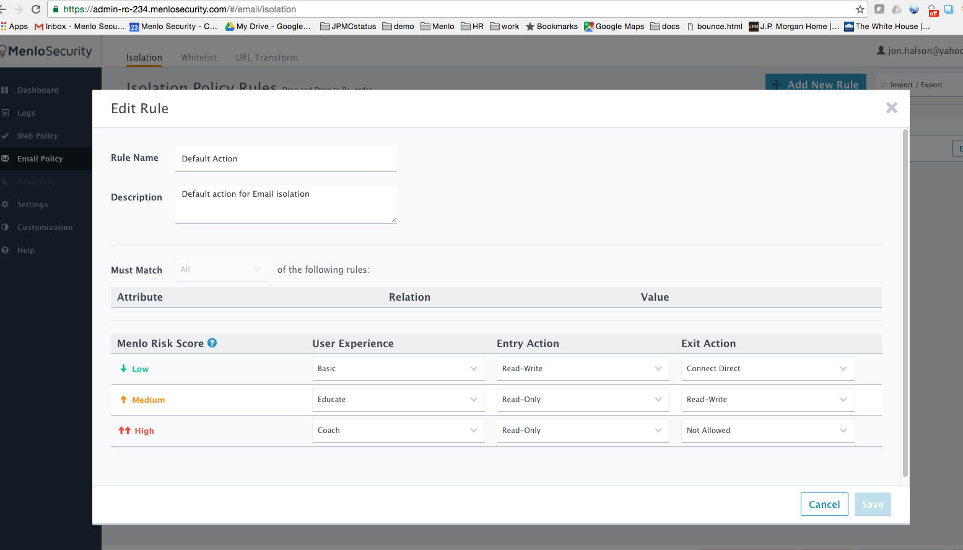Access key ID,Secret access key
AKIAIXY6TJ2UKHCL7TFQ,4kRXF17DThW/mYupfhbAIBghIwSJWfgSNy3dvkXY
Access key ID,Secret access key
AKIAIP4D7U5K4U3GSCDQ,TC3KNJdBg2Nmir0Bw


